Document No.: Doc.Ref.: XXX
Version: 01
Date: 7/12/2022

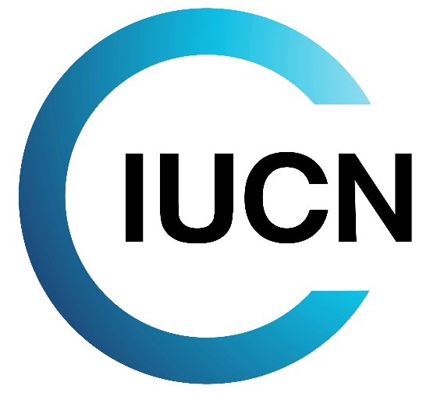

Environmental, Social and Human Rights Policy Statement

Environmental and Social Management System
Doc.Ref.: XXX |  |  |  |  |  |  |  | Version: 01
Environmental, Social and Human Rights Policy Statement
Issued on: |  | 7/12/2022
Current Version Approved by: XXX  Title: XXX  Date: XXX |  |  |  | Signature:
0 | XX/XX/2022 |  | SRA |  |  |  |  |  |  |  | First Draft
REV. | DATE |  | AUTHOR |  | CHECKED |  |  |  | APPROVED |  | MODIFICATION DETAILS
☐ | Confidential |  |  |  |  | ☐ | Internal |  |  |  | ☐ | Public

ACRONYM LIST
TERM | DEFINITION
ESMS | Environmental and Social Management System
IPLC | Indigenous Peoples and Local Communities
PMU | Project Management Unit
SADC | Southern African Development Community
TFCAs | Transfrontier Conservation Areas
TFCA FF | Transfrontier Conservation Areas Financing Facility

Environmental, Social and Human Rights Policy Statement
Transfrontier Conservation Areas (TFCAs) are founded on the realization that natural resources that straddle international boundaries are a shared asset with the potential to meaningfully contribute to the conservation of biodiversity and the welfare and socio-economic development of rural communities.
The development and establishment of a regional and sustainable TFCA financing mechanism is a major component of the Southern African Development Community (SADC) TFCA programme (2013). The Transfrontier Conservation Areas Financing Facility (TFCA FF) aims to support the overall goal of a “functional and integrated network of TFCA’s where shared natural resources are sustainably co-managed and preserved to foster socio-economic development and regional integration for the benefit of people living in and around TFCA’s, the SADC region and the world”. TFCA’s are regarded as a means of creating an enabling environment for local participation in decision making processes, increasing opportunities for investment in income generating activities for communities to improve local economies resulting in poverty reduction. The positive ecological effects of well-managed TFCAs further promotes sustainability of ecosystems and their capacity to provide the necessary goods and services required to support the sustainable development of the region through a unique level of regional cooperation amongst participating countries.
TFCAFF commits to invest in tangible measures that strengthen ecological, economic, cultural and institutional connectivity within SADC TFCAs for the management of shared natural resources and sustainable development.
This policy statement comprises TFCAFF’s commitments to always apply a rights based approach through the entire grant cycle and to work closely and continuously with indigenous peoples and local communities (IPLC) including vulnerable groups in order to promote achievement of long term conservation- and development objectives of SADC TFCA’s including equitable governance.
TFCAFF is implementing its commitments through its environmental and social management system (ESMS), in compliance with the respective national laws in the SADC TFCA’s, with international commitments and declarations signed by these TFCA countries and international environmental, social and human rights standards and best practices as specified in the ESMS.
TFCA FF will work in line with the following principles:
- Rights-based approach: to respect, protect and promote the fulfilment of human rights, most prominently the human rights framework in the Universal Declaration of Human Rights and the two international Covenants on Civil and Political Rights and on Economic, Social and Cultural Rights;
- Non-discrimination: to ensure that TFCAFF funded activities do not discriminate against specific groups (e.g., in particular gender, vulnerable/ disadvantaged groups) with regards to access to resources, services, or benefits provided by the project and that negative impacts of the project do not fall disproportionately on disadvantaged or vulnerable individuals or groups;
- Work closely with IPLC to achieve biodiversity conservation objectives on the long term, and to promote equitable governance of TFCA’s, support capacity building for equitable governance;
- Identify and assess environmental, social and human rights risks and impacts resulting from TFCAFF financing and evaluate to which extent TFCAFF granted activities are causing, contributing to or are linked with human rights and environmental and social risks and impacts;
- Support law enforcement in line with the respective national legislative frameworks and with respect for human rights by TFCAFF grantees and implementing partners and by the responsible national authorities; support capacity building for such law enforcement;
- Address health and safety of local communities affected by TFCAFF funded activities and labour conditions of project workers, workers of subcontractors and the TFCAFF itself;
- Ensure transparency about project design and identified adverse impacts through disclosure of information and engagement of stakeholders and through dedicated grievance mechanisms. accessible to all parties potentially affected by TFCAFF funded projects;
- Support the protection of cultural and natural heritage of TFCA’s on the long term;
This policy statement is endorsed by TFCA FF Steering Committee and the SADC Secretariat and will be communicated to all staff members of the Project Management Unit (PMU) (the Facility), IUCN ESARO as well as to partners and grantees of the Facility.
This policy statement will be reviewed regularly as part of the management review of TFCAFF’s ESMS.

